Agenda for Today:
- Topics from Last Week
- Migration Summary
- Update on Automation
- Curtisswright.com
  - Walkthrough of Weekly Web Analytics of Curtisswright.com
    - Google Analytics: Link
Summary Report For Migration Websites (Batch 3):
Website | Owner | Completed Tasks | Upcoming Tasks | Clarifications/Requests
CW Phase 2.0 - Planning | Sai Krishna V | Received pptx file from Darren.  Had a detailed discussed with CW-Defense understood their requirements  We analyzed the requirement of CW-defense  CW Defense — DS Web 2.0 : Requirements via Implementation - 20 Topics - Internal (To be shared with Dave)  Based on Weekly Discussion with the defense team, we are working on migration planning on merging Curtisswright.com and CW defense.  We will look at all the schema, data objects, and forms and do a detailed technical analysis on the merger of these two sites (including conflicts, issues, and naming or taxonomy changes).  Defense Analysis :  CW Web2 - Migration_Plan - DS | Internally discussed the design standards.  Creating a Drupal theme (CSS, JS specific to 2.0 mockups) will be installed on the 2.0 development site.  ---  Approved Templates by End of March 2026  (After Exec Review, Dev Starts by April 7th 2026) | CW 2.0 Menu - Live Mockup : https://www.figma.com/proto/t7KTn7Ej7vEzlJymIsHYWE/Curtiss-Wright-Web-2.0?page-id=2093%3A2&node-id=3656-7961&viewport=-12031%2C2694%2C0.13&t=6qQFSIp7miNANbgF-1&scaling=min-zoom&content-scaling=fixed&starting-point-node-id=3656%3A7961  Components : https://www.figma.com/proto/t7KTn7Ej7vEzlJymIsHYWE/Curtiss-Wright-Web-2.0?node-id=3152-5006&starting-point-node-id=3152%3A5006  Phase 2.0 - Homepage Design preview Curtiss-Wright Phase 2.0 - Home page.pdf  CW 2.0 Header Navigation UX process.pdf  Figma file link:  CW 2.0 Navigation changes - Option 1  Web Phase 2.0 _ Navigation Corporate + Division.pdf  Brand Guide is completed ☑️  Curtiss-Wright Design product pages Web 2.0.pdfCW Web-2.0 Style guide updated.pdf  Style Guide_abbreviated.pdf  Mobile Navigation  https://www.figma.com/proto/t7KTn7Ej7vEzlJymIsHYWE/Curtiss-Wright-Web-2.0?page-id=2002%3A10257&node-id=3954-11301&viewport=256%2C203%2C0.08&t=yCiocNbsJodW8QTc-1&scaling=scale-down&content-scaling=fixed&starting-point-node-id=3954%3A11301  1. Web 2.0 Typography ☑️  2. CW Web 2.0 Font ☑️  CW Web 2.0 - Font Compaision.pdf  3. News Page Design✅  CW 2.0 - News Page Layout Design Mockups.pdf  4. Market and Organisation Page Design ✅  Figma File Link,  Markets page Figma Preview Link,  Organizations page view  5. Product Grid Component ✅ Figma Preview link
CW Phase 2.0 : CW Common Theme Development | Sunil Kumar | - Completed the mapping of content types, site structure, navigation, Views, and the header and footer ✅  - The Sensor site migration and testing have been completed ✅ | Working and Creating all the updated components on development environment  https://cw-2-0-sandbox-dev.curtisswright.com/cw-2-0-components  Working on Navigation and News Page Updated Design | https://cw-2-0-sandbox.curtisswright.com/sensors  https://cw-2-0-sandbox.curtisswright.com/cw-2-0-components-home
Web refresh | Britto Raj Shilpa Patil Divya MSunil Kumar | Curtiss-Wright - Completed and sent for review ✅  EMS - Completed and sent for review ✅  Valves - Completed and sent for review ✅  Sensors - Completed and sent for review ✅  Nuclear Completed and sent for review ✅  Surface Tech - Completed and sent for review ✅  Actuation - Completed and sent for review ✅  Industrial - Completed and sent for review ✅ |  | - All sites Web Refresh 2.0 are completed and awaiting for feedback.✅  - Completed CW Web Refresh Changes and sent for review.✅
Surface Technologies Translation Sites/Content | https://surfacetechnologies.curtisswright.com/  Nihar / Sindhu | Completed the translations for the French, Polish, Spanish, Chinese, and German languages on Live. ✅ | Preparing to go live Hungarian Translations.☑️ | Phase 2.0:  We got approval from Amanda. We are doing final sanity checks before pushing hungarian language to live.☑️  Followed up with Amanda regarding the Romanian translations. ☑️
Surface Technologies - Searchable Approvals Database | Divya M | TG Approvals 2025  Ref : https://www.valencesurfacetech.com/approvals/ | https://cwstcomstage.prod.acquia-sites.com/searchable-database | The data import and functionality are completed from our end.  Waiting for the correct database list.  Sent a followup email ✅
Searchstax | Rohan Gurav |  | A custom module is developed. ✅  https:/curtisswright.com/search | Analytics Report  .  Required: Defence Google Analytics Measurement ID to track user search queries on the website for SEO analysis and improvements.  Pending fix: Add $base_url to settings.php on all 9 CW sites so that Drupal’s auto-reindex captures the correct site URL instead of falling back to http://default/ — this will permanently stop the recurring broken links in search results without needing manual reindexing.
SEO Optimisation for curtisswright.com | Sofia Krishnan | - Completed the Technical SEO audit of Surface Technologies regional location pages Spanish, Polish, Chinese, & English and shared the recommendation plan.✅ | - Working on optimizing page meta titles, description for the Surface Tech site. (Ticket No :INC0224386)  - Working on implementing a recommendation plan for France,Sweden, Norway, and Finland pages. | Sofia is working on the SEO Analysis of CW Business Sites (We have completed Surface Tech earlier)
CW Actuation Portal  https://portal.cw-actuation.com/  Live ✅  Monitoring and Supporting | Rohan Gurav | Live: portal.cw-actuation.com |  | Learning Management System (LMS) is completed ✅ and currently waiting for the IT block to be released.  LMS Training Portal - Feature Delivery & Task Tracker-Hold☑️  - Worked on the Price Configurator changes requested by Bonnie. ✅  - Worked on the delete user functionality for the approved channel list. ✅  - Worked on the GSX product issue on the live site. ✅
Everlube | Divya M | everlubeproducts.com  Everlube Site Summary Document  Completed Layouts : 2/28  Completed Pages Migrated: 0/154 | https://cwstcomdev.prod.acquia-sites.com/our-services/everlubeproducts  Pending Layouts : 26/28  Completed Pages Migrated: 0/154 | Completed the Header and Footer Section.  Working on the Unique layouts.
IMR test Labs  http://imrtest.com/ | Shilpa Patil | IMR Site Summary Document  Completed Layouts : 02/52  Completed Pages Migrated: 0/182 | Pending layouts: 50/52  Pending Pages : 182/182 | No updates this week  Migration will start after 2.0 web refresh.
Keronite | Britto Raj | keronite.com | keronite Site Summary Document | Evaluation of the site is completed and sent for review. ✅  Working on the Unique layouts.
Nuclear | Sunil Kumar | - Integrate ultra.energy (cwic.curtisswright.com)  - Integrate 3keysoft.com / ws-corp.com  - Integrate cw-connect.com  - Evaluate store.ultra.energy (cwicstore.curtsisswright.com) | WS-Corp Site Summary Document | It's on hold.  cwic.curtisswright.com  New page content will be provided by the end of October, which will be added directly to the Nuclear site.

Topics from Last Week
Topic | Details | Question/Clarification/Update
Few Low Priority Topics |  | CW October 2026 Events and PR ?  Curtiss-Wright Announces $30 Million Capital Investment to Expand Its Operations in Round Rock, Texas ✅
Bluefly Topics  Accessibility & SEO Improvements  Performance Optimization | Rasheed suggested CW SEO Topics and Scope. | CW <> Bluefly <> Etag - Topics Tracker  - CSP headers (Javascript + CSP Best Practices) - Completed EMS,Actuation Site ✅ Working on Industrial dev and valves stage site as per Rasheed guidance to fix font and style src hashing ☑️  - Autodiscover and missing blocks ☑️  - Working on Press release Date appending with title for all press releases on live site. (Completed year - 2002 to 2020) ☑️ - Will be continued after 2.0 web refresh  - Webform Module: The Counter Problem ☑️ (Testing few Drupal modules to implement Queuing process) - Will be continued after 2.0 web refresh  - Security updates completed for all the sites ✅
Drupal 10 EOL by December | Drupal 10 to be updated to 11 | All sites will be updated to Drupal 11 after completing web refresh 2.0 ☑️  Need Drupal 11 compatible Codesk theme.
Business Wire (quotemedia) API | Working on creating a custom Drupal module. | - The module has been pushed to the dev environment. We will check the automatic content creation when the next press release is published.  https://curtisswrightcomdev.prod.acquia-sites.com/news/press-releases/news-release-details/2026/Curtiss-Wright-Announces-30-Million-Capital-Investment-to-Expand-Its-Operations-in-Round-Rock-Texas

Analytics, Monsido, and Webmaster Console:

Analytics | https://analytics.google.com/analytics/web/#/p432579895/reports/intelligenthome
Webmasters Console | https://search.google.com/search-console?utm_source=about-page&resource_id=sc-domain:curtisswright.com
Monsido (Acquia Optimize) | https://new.monsido.com/

Analytics
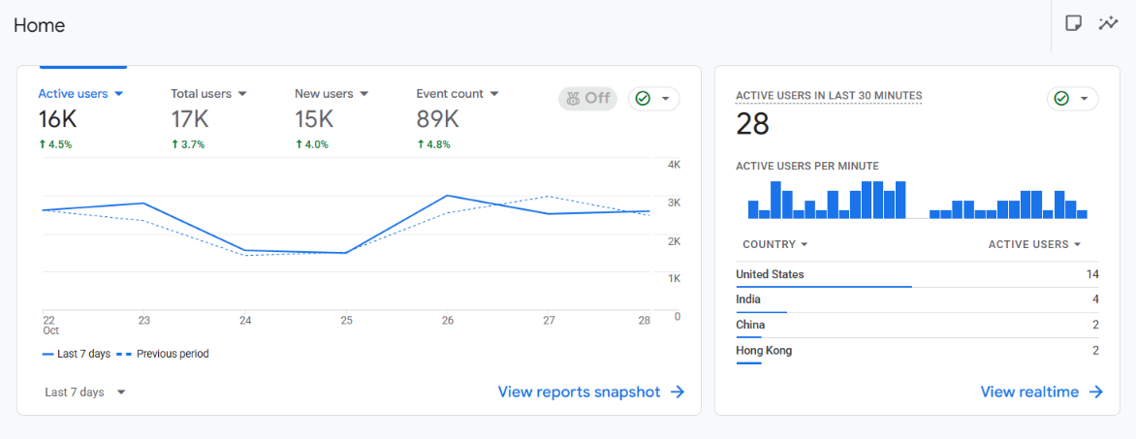
Monsido

